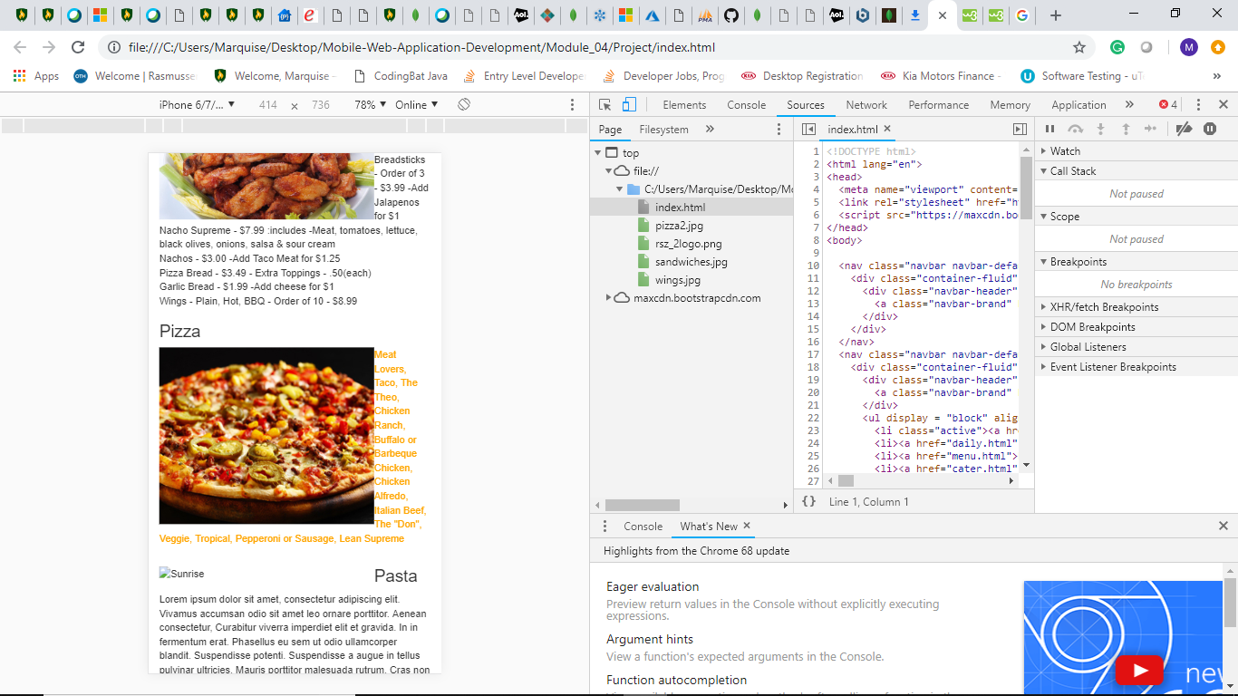

In this particular case, I changed the color of the text for the food description. I do not believe this will be a feature that will be carried over for the final version of the webpage. Changing this color does not affect the usability of the page. However, it does not visually look appealing and does not assist in conveying the message. 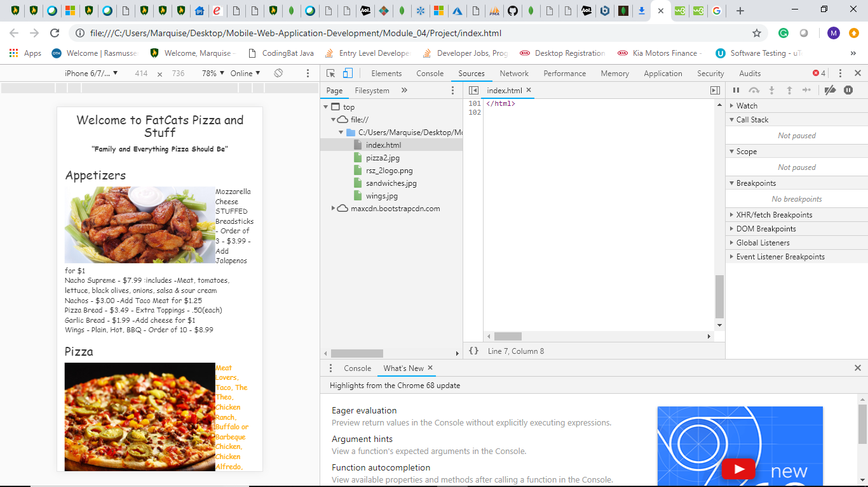

In this particular case, I changed the body text to comic-san. The comic-san font does not look well on the description of the food. I believe the font might remain for the menu items though going forward. It seems to add slightly more authenticity to the page. I do not see any issues that would affect viewing experience thus far. 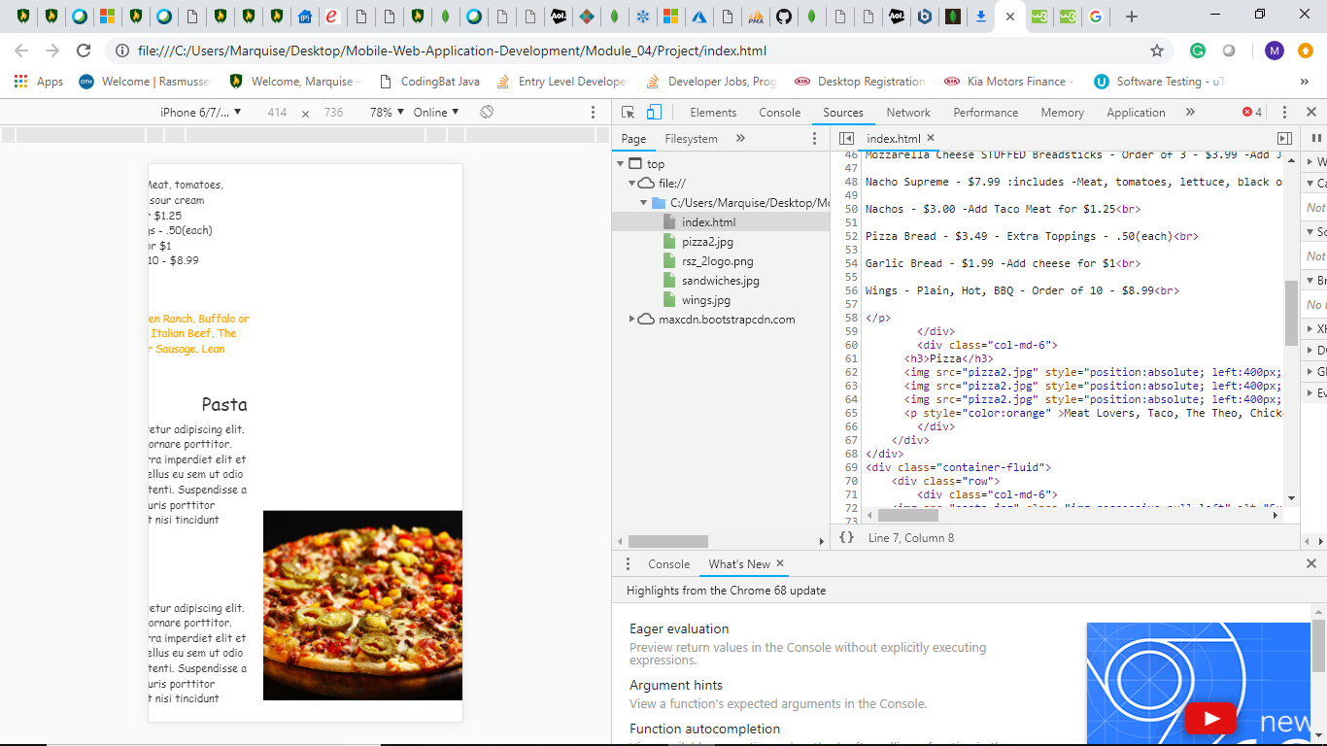

In this case, I changed the location of the picture and attempted to overlap them. This would affect the user experience as the user has to drag the screen over to view it. Additionally, it throws the text off for the view as well. I would most definitely not include this in my final version as it causes far too many issues.